**Team J4 + b:** LA Delay Optimization

Jerry Chen

Jack Wegleitner

John Stuart  
Jules Pommies  
Brian Tam

------------------------------------------------------------------------------------------------------------------

1. Progress that has been made since last week  
2. Goals for the upcoming week  
3. Any problems/difficulties that your group has encountered so far

**1. Progress**

**Optimization Program Coding:**

* Fully formulated the constraint matrix for analyzing arrivals. Coding in progress.
* Modeling extra travel time added to a route by change of airport as a vector of airtimes determined by the approach direction. Actual approach directions will be analyzed at a later date for different routes and aircraft models. For simplicity, they are now being approximated by cardinal directions with additional flight times extracted from google maps.
* Focus for this week will be on making a functional code and them moving on to add complexity for more accurate modeling.
* Started to generate initial data visuals. We are studying these plots and graphs to see if there are any patterns we could look at more closely to help the efficiency of our optimization. We generated graphs for both airport delays and airline delays in the LA basin.

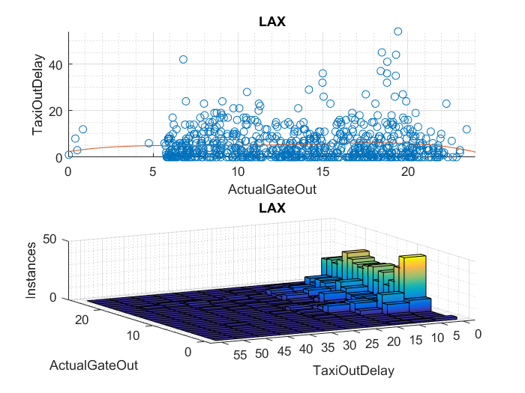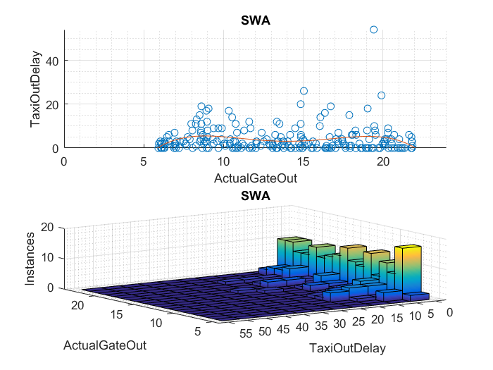

Sample Code:

|  |
| --- |
| Representing additional flight time from change of route in constraint matrix A |
| for i= 1:N % for each aircraft, assign potential additional flight time by approach direction  if Origin(i)=1 %North  A(i,N+R*i)= ATadd(1); %assemble x components of t constraints (for i runways)  elseif Origin(i)=1 %East  A(i,N+R*i)= ATadd(2) %air times extracted from matrix ATadd of flight times;  elseif Origin(i)=1 %East  A(i,N+R*i)= ATadd(3);  else  A(i,N+R*i)= ATadd(4);  end  end |

|  |
| --- |
| Framework for order of arrival constraints using the Big M Method |
| for i=1:N %assemble t components of all arrival order constraints (tcons)    for k=1:N  if i>k  A((2*MRow-1:2*MRow)+2*N+xcons,i)=binCo; %assemble t components of Mcons  A((2*MRow-1:2*MRow)+2*N+xcons,k)=-binCo; %assemble t components of Mcons  MRow=MRow+1; %iterate to next constraint pair  end  end  end |

Updated Constraints (added effect of independent runway queues):

|  |  |
| --- | --- |
| Purpose | Constraint |
| Wheels on time equals estimated air time + additional rerouting time + hold delay +approach delay (Aeq) |  |
| Delay limit per A/C |  |
| Single destination constraint |  |
| Minimum headway constraint (inactive for A/C with different destinations) | equation preview |
| Runway capability constraint |  |

**2. Goals**

* This coming week we would like to have output data from our program, and have the framework for mixed operations to implement
* Using output data, we will begin analyzing the effects of changes such as arrival time error, fleet mix etc. as mentioned in progress report 1.
* Continue producing data visualizations for delay and capacity over time.
* Find data that can translate tail numbers into A/C model, size category, and fuel efficiency. Use this data for determining lead times and cost savings.
* Analyze modal split of airport access in LA.

Long term goals: Develop a policy strategy for implementation using and output cost data as a baseline for feasibility and magnitude or type of incentives.

**3. Difficulties**

* Turning tail numbers into weight categories for determining A/C follow times and sequencing in an efficient manner has been difficult. We will look for a solution to this in ASPM and other databases.
* Lack of information on beginning of descent times add a lot of guesswork and assumptions to the estimation of air delays, since it will be difficult to tell how much of the delay is due to terminal airspace congestion and how much is due to outside factors.